### The Peach State Traveler

**Year 30 Issue 09~ FMCA PST Chapter Newsletter ~ September 2022**

**2022 Officers**

President: Terri Jones 404-925-6440

Vice President:

Treasurer: Terry Carlyle                                  706-654-1188

Secretary: Kenlyn Sawyer                              404-867-3898

National Director: Marvin Voyna                   678-472-4302

Alternate Natl. Director –

**2022 PST Appointees**

Wagon Master: Libba Gruba 770-365-6111

Sunshine Chair: Marge Esposito

Newsletter Editor: Patricia Voyna              678-523-0378

Directory Editor:

Membership Chair: Beth Bennett 404-317-1018

Chaplain: Jim Hollis 770-402-6074

**FMCA National Officers**

President – Rett Porter III

Sr V President – Gary Milner

Secretary – Kathie Balogh

Treasurer – Barbara Smith

**Future SEA (Southeast Area) Rally**

[www.seafmca.org](http://www.seafmca.org)

SEA President–Patricia Voyna email:

[pfvoyna@marvsdiesel.com](mailto:pfvoyna@marvsdiesel.com)

SEA Georgia VP –

February 7-10, 2024, SUN n FUN, Lakeland, Florida

**Future FMCA International Convention**

Summer 2022 – August 24-27 Lincoln, Nebr.

Winter 2023 – March 15-18, Perry, GA

Summer 2023 – August 23-26, Gillette, WY

Winter 2025 – March 12-15, Perry, GQ

Summer 2027 – July 14-17, Gillette, WY

*\* = Contingent on successful contract negotiations.*

**2022 RALLY HOSTS**

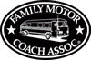**Wagon Master – Libba Gruba**

Weekend different from 1st weekend.

**Special rally due to distance from Atlanta

###Our Bylaws require members to host a rally. Ideally, three couples should be able to manage a great rally weekend.

September 2-4 Lake Blackshear, Cordele, GA

*Loudermilk & Simons*

October 7-9 Crossroads Travel Park 478- 987-3141

1513 Sam Nunn Blvd Perry Ga

*NO HOST*

November 4-6 River Rocks Landing 256-292- 7956

1 River Rd. Gadsden Al

*No HOST or Sawyers*

December – St. Mt. RV Park 770-498- 5710

4003 Stonewall Jackson Dr. St. Mt. Ga

*Club Officers*

**2023 RALLY HOSTS**

**January 7** Luncheon TBD

*Moreman*

**February 4** Luncheon TBD

*Simons*

**March 15-18** FMCA International Convention, Perry, GA

*Voyna* & ? (Lunch on March 13 or 14th)

**April 7-9** – Leisure Acres, Cleveland, GA

706-865-6466

*Vangys, Sawyers*

**May 5-7** – Hard Labor Creek State, Rutledge, GA

800-864-7275

*Gruba*

**June 2-4** – TBD

*Simons*

**July 7-9** – Luncheon, Dawsonville

*Carlyle*

**August 4-6** – TBD

*Esposito*

**September 1-3** – TBD

*Glenn*

October 6-8

November 3-5

**December 1-3** Club Officers

**PRESIDENTS CORNER – August 2022**

We are planning to host the **May 5-7, 2023** rally at:

HARD LABOR CREEK STATE PARK

5 Hard Labor Creek Rd - Rutledge, GA

ASAP Reservations Need to be madeis a state park.

Please call AUTUMN at 800-864-7275

They have several sites with Full Hookups, but they go fast.  I know this is a long time away, but we can cancel up to 3 days before with a $10 fee.

This is a very nice park that is spaced out nicely.  I have also reserved the pavilion for Friday & Saturday.

Please let me know when you have made your reservations. Thanks, Libba & Ed Gruba

By Terri Jones

Willow Valley never disappoints.  It is nestled in the mountains of fresh air and rain. It was a beautiful restaurant with a small quaint town of Dillard..

Bill and Marge Esposito were the perfect host and hostess.  We were treated to a meet and greet on Fri evening with wine and cheese tray, then served a delicious Stuffed Shell dish with homemade sauce ( Bill created) along with salad and garlic bread.  Ice ream sundaes were served along with an Apple cake honoring Boyd Carlyle ( cake by Terry)

Very nice items were donated by Tom Tripp that were accepted by some members for their RV’s. White elephant exchange went well without too many gifts being traded.

Clayton Café was a great little breakfast spot on Saturday morning, too early for some shops but it felt like early fall.  Once again dinner did not disappoint-.Hot dogs, assorted sides provided by attendees, fresh fruit, cherry cobbler with ice cream.  YUM YUM.. Don’t miss out on these meals again.

Sunday morning will come early and everyone will be heading out back home. Me, I have about a 10 hour  ride back to Florida but ready to get home.

Until we meet again.

Hope that you can join us all in September at Lake Blackshear.

Respectfully, Terri Jones, President PST

**PRESIDENTS CORNER – September 2022**

By Terri Jones

Getting things together for the September Rally at Lake Blackshear. Tuesday told me different. Little feverish and test showed positive. I felt good off and on but staying away for others health was more important.

The campground looked great and the lake views were beautiful.  Don and Donna Loudermilk and Alan and Debbie Simons were great hosts as expected and I heard the games and food was all great.

I look forward to seeing everyone in Oct .

Safe Travels and HELLO FALL!!

Respectfully,

Terri Jones

President-PST

**NATIONAL DIRECTOR REPORT**

By Marvin Voyna

Only 2 things to vote on. 1st – Taking require officers from 5 to 4. Since the Secretary and Treasurer can combine, that means the National Director can also be the President or combined with the VP. This is to help the chapters that have trouble finding officers.

The 2nd was presented by the Long-Range Planning Committee to create a target market for ages 55 – 65 years old, empty nesters, getting ready to retire, etc. Big push back from the floor. National Directors, some who felt they weren’t wanted in FMCA. An additional target area was added, 35-55 years of age, which would have children, perhaps homeschool, vacations, etc.

It was brought to our attention, only 2 ways to create money to keep FMCA the best for RVers is a raise dues or find new members. Also, this one is going to sit you down. FMCA is not a major player among RV owners (.69%) and not even a key player among motorhome owners (3.3%) Although we are still the largest non-profit organization in the world.

**SECRETARY REPORT- September 2022**

By Kenlyn Sawyer

The September 2022 Rally was held at the Lake Blackshear Resort and Golf Club in Cordele on September 2 -5, 2022. Hosts were Don and Donna Loudermilk and Alan and Debbi Simons. There was a total of 11 people in attendance for the weekend. Names of those in attendance are at the end of this report.

President Terri Jones was conferenced in via phone for the meeting on Saturday, September 3, 2022, at the Lake Blackshear campground and thanked everyone for attending the weekend and was sorry that she was unable to attend. She also expressed appreciation to Don and Donna Loudermilk and Alan and Debbi Simons for hosting the weekend.

Wagon Master, Libba Gruba made announcements for upcoming 2022 rallies. Please contact Libba Gruba to sign up for a 2022 or 20223 rally. Please contact your hosts to confirm your attendance after the campground reservations are made.

October 7 – 9, 2022 – Crossroads Travel RV Park – Perry, GA “No Host Rally”

November 4 – 6. 2022 – River Rocks Landing – Gadsden, AL “No Host Rally”.

December 2 – 4, 2022 – Stone Mountain Campground - PST Officers

Libba Gruba made a motion to close the meeting and Don Loudermilk seconded the motion.

MEMBERS: Bennett; Glenn; Gruba; Loudermilk; Sawyer; Simons.

**Brain Teaser**

It’s in the church, but not in the steeple; It’s in the person, but not in the people; It’s in the oyster, but not in the shell; It’s in the clapper, but not in the bell. What is it?

(See page 2 for answer)

**RALLY REPORT – September 2022**

By Donna Loudermilk

Peach State Travelers September rally was held at Lake Blackshear Resort & Golf Club in Cordele  
September 1 - September 5  
Hosts:  Don & Donna Loudermilk with Alan & Debbi Simons  
Attendees:   Sawyer, Bennett, Grubba, Glenn, Loudermilk, Simons  
  
This turned out to be the rally where we literally planned everything around heavy rain and thunder.  
  
Thursday September 1 was cloudy with a prediction of rain at dinner hour.   Everyone was agreeable to escape the rain and try out a local Mexican restaurant, Pancho’s.  
  
Friday morning, the hosts served a bountiful breakfast in the Activity Center.   After breakfast many toured the indoor and outdoor Veterans Memorial Museum on the grounds of Lake Blackshear.   This Museum pays a tribute to veterans with vintage memorabilia from Revolutionary War through the present day.   The outdoor display included jets, helicopter, tanks, landing craft and artillery.   John, Ed and Don each shared memories serving in the military.    Many explored downtown Cordele and then we met back at Activity Center for a social followed by hamburgers and hot dogs.  While eating ice cream sundaes and buttery pound cake, each shared about a “tool” or item they brought to make their lives easier when traveling in RV.  
  
Saturday everyone enjoyed breakfast at Simons campsite.   Ed & Alan decided to try out their kayaks on Lake Blackshear.   Loudermilks drove over to Plains and visited Jimmy Carter’s boyhood farm and walked around downtown Plains.   Everyone enjoyed a day of relaxing before we met for dinner at Daphne’s Lodge.   Daphne’s served a variety of delicious seafood dishes.    The rain made its way into our evening plans.   On our way back to the campsite, lots of deer were seen eating the fresh wet grass.  
  
Sunday everyone met at Cordelia’s which is located on Lake Blackshear for breakfast buffet.   After breakfast the rains started again and was sporadic throughout the day.   We decided on dinner at an early hour with a potluck/crockpot but a downpour with thunder popped up.    We all consulted the weather forecast app and picked another time to bring our food over to the Simons site.   We finally enjoyed our dinner under gazebo and shared our most memorable RV destinations with each other.  
  
Lots of goodbyes and safe travels were shared until we meet again at October rally.

**SUNSHINE REPORT – September 2022**

****By

**TREASURES’S REPORT March 2022**

By: Terry Carlyle

Beginning Balance 09-30--2021 $2,343.92

Receipts: Sept. Rally 3.70

Oct. Rally 8.18

Nov. Rally 49.65

Dec. Rally 12.00

Jan. Rally 15.00

Feb. Rally 10.00

March Rally 17.00

Dues 270.00

Disbursements:

Presidents Gift 50.00

Registration with state 30.00

Barbara VanGuys Memorial 100

Ending Balance 03-07-2022 $2,549.45

***EVERYONE MUST COMPLETE A RALLY REPORT AND SEND TO ME FOR THEIR RALLY. PLEASE SEND ALL RECEIPTS WITH IT!!!!!.3***

**Birthdays**

09-05 – Brenda Ralston

09-09 – Joe Like

09-25 – Gary Bray

**Anniversaries**

09-05 – Gene & Beth Richardson

09-29 – Mike & Judy Hughes

**What is the Original Meaning of Jubilee?**

A jubilee conjures in the imagination a time of celebration or abundance. The concept has religious origins.

In the Bible’s Old Testament, every seven years, a jubilee provided a structure for land management. People would abstain from farming to let the land rest.

Seven years also marked a time to cancel debts and release enslaved Hebrews. Furthermore, every 50th year was a time when Hebrew slaves were set free, and their lands returned to them.

A jubilee was also a religious song enslaved African Americans sang. It usually refers to a time of future happiness free from oppression.

Over time, jubilees took on a broader significance. In the United Kingdom, royal jubilees became an opportunity to celebrate the life and long reign of a monarch.

Her late majesty, Queen Elizabeth II, celebrated an amazing 70-year reign. Crowds throughout the commonwealth celebrated her Platinum Jubilee with parties and activities of traditional significance.

**Brain teaser answer:**

The letter R

 **October rally info**

**Please send out. Sign up asap**

**Crossroads RV park**

**Perry GA**

**The fair will be at the fair grounds.  Oct 7-9**

**No host**

**478-987-3141**

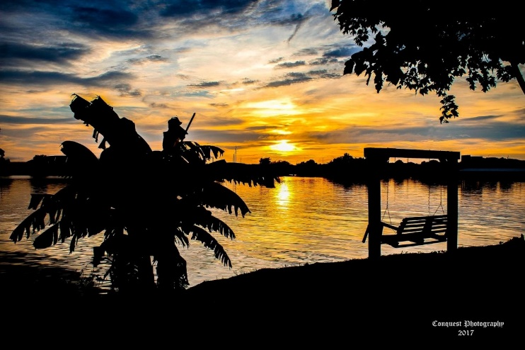

**Please make your reservations now for the**

**"No Host" Rally in**

**November**

**at River Rocks Landing in Gadsden, AL** -

**Please note the Bay Lodge is only complimentary if we have a total of 12 sites**.

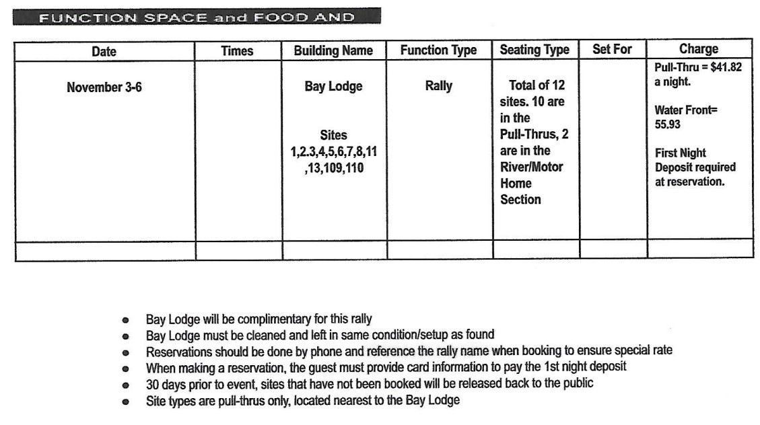  
More details to follow.... **Have a GREAT Day!**

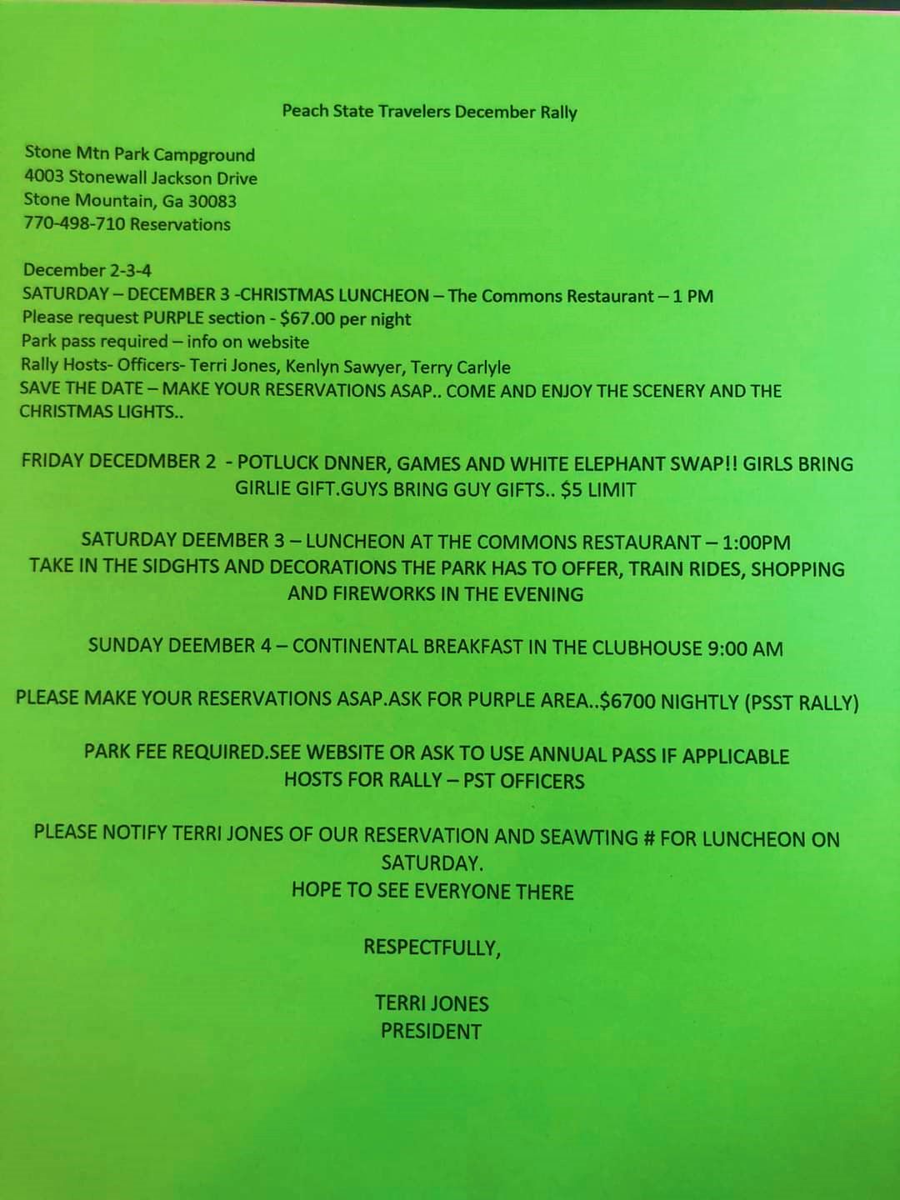



**From**

**Patricia Voyna**

**PO Box 1315**

**Conyers, GA 30012-1315**

**PST Newsletter – September 2022**

**IN GOD WE TRUST**



